DEPARTMENT OF COMPUTER SCIENCE AND ENGINEERING
Bachelor of Technology – 3rd Year Project Report

PROJECT REPORT
Academic Year of 2027

StackPilot: Full Stack CI/CD Deployment Platform

Using

React.js, Node.js, Docker, Docker Compose, Jenkins and GitHub Actions 

Guided by : Tiyas Sarkar
Submitted by : Adepu Lakshmi Srinivas
Reg No : 12308069

Abstract

This project presents the design, development, and deployment of StackPilot: Full Stack CI/CD Deployment Platform, a modern web application deployment system that automates the process of building, testing, containerizing, and deploying full-stack applications using contemporary DevOps practices. The platform is developed using React.js for the frontend user interface, Node.js and Express.js for backend API services, and MongoDB as the primary database system. The project integrates Docker containerization and Docker Compose orchestration to ensure consistent and reproducible environments across development, testing, and deployment stages.
To address challenges associated with manual deployments, dependency conflicts, environment inconsistencies, and inefficient release workflows, the system implements a fully automated Continuous Integration and Continuous Deployment (CI/CD) pipeline using GitHub Actions and Jenkins. The CI/CD workflow automates source code integration, dependency installation, application testing, Docker image creation, container registry management, and deployment processes with minimal human intervention. The platform enables developers to achieve faster and more reliable software delivery while reducing deployment errors and improving overall development productivity.
The application architecture follows a containerized microservices-inspired approach in which frontend, backend, and database services operate within isolated Docker containers communicating through Docker networks. Automated workflows validate application builds, execute test cases, and deploy updated services whenever changes are pushed to the GitHub repository. The system has been tested for deployment reliability, container availability, pipeline automation, and service integration, demonstrating successful automated builds, stable multi-container execution, and streamlined deployment operations.
This report documents the complete lifecycle of the project, including problem identification, system architecture, technology stack selection, implementation methodology, CI/CD workflow configuration, Docker orchestration, testing strategies, deployment validation, and future enhancement opportunities. The project demonstrates the practical application of DevOps principles, automation tools, and containerization technologies in developing scalable and maintainable software delivery systems.
Keywords: DevOps, CI/CD Pipeline, Docker, Docker Compose, Jenkins, GitHub Actions, Node.js, React.js, MongoDB, Containerization, Automation, Full Stack Deployment, Microservices.

Introduction
The rapid growth of modern software applications and cloud-based services has significantly increased the demand for faster, more reliable, and automated software deployment processes. Traditional software deployment methods often rely heavily on manual configuration, testing, and deployment procedures, which are time-consuming, error-prone, and difficult to maintain across different development and production environments. Development teams frequently encounter issues such as dependency conflicts, inconsistent runtime environments, delayed releases, and deployment failures, all of which reduce productivity and affect software quality. As organizations move toward agile development and continuous software delivery, the need for efficient DevOps practices has become increasingly important. Simultaneously, the adoption of containerization technologies has transformed the way modern applications are developed and deployed. Docker enables developers to package applications along with all required dependencies into lightweight, portable containers that can run consistently across multiple environments. Docker Compose further simplifies the management of multi-service applications by allowing developers to define and orchestrate frontend, backend, database, and networking services using a single configuration file. These technologies eliminate the traditional “it works on my machine” problem and provide a reproducible and scalable deployment environment. In addition to containerization, Continuous Integration and Continuous Deployment (CI/CD) pipelines have become essential components of modern software engineering workflows. CI/CD systems automate repetitive tasks such as code integration, dependency installation, application testing, Docker image building, and deployment. Tools such as GitHub Actions and Jenkins help development teams deliver software updates rapidly and reliably while maintaining high code quality through automated validation and testing processes. Automated pipelines reduce deployment risks, minimize downtime, and improve collaboration among development teams by ensuring that every code change is tested and deployed consistently. This project combines these modern DevOps concepts to develop StackPilot: Full Stack CI/CD Deployment Platform, a production-oriented deployment automation system built using React.js, Node.js, Docker, Docker Compose, Jenkins, and GitHub Actions. The project demonstrates how a full-stack web application can be containerized, tested, integrated, and deployed automatically using a complete DevOps workflow. The platform automates the software delivery lifecycle, including source code management, container image generation, pipeline execution, service orchestration, and deployment validation. By integrating multiple DevOps tools into a unified workflow, the system improves deployment efficiency, reduces manual intervention, and ensures consistency across development and production environments. The remainder of this report is organized as follows: Section 2 discusses the problem statement addressed by the project, followed by the objectives and scope in Sections 3 and 4 respectively. Section 5 presents the literature review and existing technologies related to DevOps and CI/CD systems. Sections 6 through 10 describe the system architecture, technology stack, implementation methodology, Docker orchestration, and CI/CD workflow in detail. Section 11 explains the testing and validation procedures, while Section 12 presents the outputs and observations obtained during implementation. Finally, Sections 13 through 16 discuss the advantages, limitations, future scope, and conclusion of the project.

Problem Statement

Traditional software deployment and application management processes face several critical challenges in modern development environments. Many organizations still rely on manual deployment methods, which are time-consuming, error-prone, and difficult to maintain. Inconsistent configurations between development, testing, and production environments often lead to unexpected failures and deployment issues, making debugging and maintenance complex for development teams.
Additionally, the absence of automated testing and continuous integration workflows increases the risk of faulty code reaching production environments. Manual build and deployment procedures also slow down software delivery and reduce overall development productivity. Managing multi-service applications without proper containerization further creates dependency conflicts and scalability limitations.
This project addresses these challenges by developing a Full Stack CI/CD Deployment Platform that automates application building, testing, containerization, and deployment using modern DevOps tools and practices. The system uses Docker and Docker Compose for consistent multi-container deployment, while GitHub Actions and Jenkins automate the CI/CD workflow to ensure faster, reliable, and reproducible software delivery. The primary goal is to build a scalable, maintainable, and automated deployment platform that simplifies modern application deployment processes.

Objectives of the Project

The primary and secondary objectives of this project are enumerated below:
- To design and implement a full-stack deployment platform that automates the build, testing, and deployment process of modern web applications.
- To develop a frontend interface using React.js and backend services using Node.js and Express.js for efficient application management and deployment operations.
- To integrate Docker containerization for frontend, backend, and database services to ensure portability and environment consistency across development and production stages.
- To configure Docker Compose for managing and orchestrating multiple application containers using a single configuration file.
- To implement a Continuous Integration and Continuous Deployment (CI/CD) pipeline using GitHub Actions and Jenkins for automated software delivery.
- To automate application testing, Docker image generation, and deployment workflows triggered by source code updates in the GitHub repository.
- To establish a reliable and reproducible deployment environment that minimizes manual intervention and reduces deployment-related errors.
- To validate the functionality and performance of the system through container testing, pipeline verification, and deployment monitoring.
- To improve software delivery efficiency, scalability, and maintainability using modern DevOps tools and automation practices.
- To document the complete project workflow, architecture, implementation steps, and deployment process for future development and maintenance purposes.

Scope of the Project

The scope of this project includes full-stack application deployment, containerization, CI/CD automation, and DevOps workflow management. The project focuses on developing a modern deployment platform that integrates frontend services, backend APIs, database management, Docker containerization, and automated deployment pipelines. The system demonstrates how DevOps tools and practices can simplify software delivery, improve deployment reliability, and maintain consistency across development and production environments.
4.1 In-Scope Features
The following features and components are included within the scope of the project:
• Development of a full-stack application using React.js, Node.js, and Express.js.
• Implementation of RESTful APIs for application communication and service integration.
• Docker containerization of frontend, backend, and database services for environment consistency and portability.
• Configuration of Docker Compose for multi-container application orchestration.
• Integration of GitHub for source code management and version control.
• Implementation of automated CI/CD pipelines using GitHub Actions and Jenkins.
• Automated application build, testing, Docker image creation, and deployment workflows.
• Deployment validation and container health monitoring.
• Environment configuration and service management using containerized architecture.
• Documentation of deployment procedures, workflow automation, and implementation details.
4.2 Out-of-Scope Features
The following features are considered valuable future enhancements but are outside the current scope of the project:
• Kubernetes-based container orchestration and horizontal auto-scaling.
• Cloud-native deployment on AWS, Azure, or Google Cloud platforms.
• AI-based deployment monitoring and predictive failure analysis.
• Advanced DevSecOps integration with automated vulnerability scanning.
• Mobile application support and native mobile deployment.
• Multi-server distributed deployment and load balancing.
• Real-time infrastructure monitoring dashboards and analytics systems.

5. Literature Review

A comprehensive review of existing technologies and modern software deployment practices has been conducted to understand the current advancements in DevOps automation, containerization, and CI/CD pipeline implementation. The review focuses on three major areas relevant to this project: containerization technologies, microservices architecture, and Continuous Integration/Continuous Deployment (CI/CD) practices.
5.1 Containerization and Docker Technologies
Containerization has become one of the most important technologies in modern software development and deployment. Docker, introduced by Solomon Hykes in 2013, revolutionized application deployment by enabling developers to package applications along with their dependencies into lightweight and portable containers. Docker containers ensure that applications run consistently across development, testing, and production environments, eliminating dependency and configuration-related issues.
Docker Compose further extends containerization by allowing multiple services such as frontend, backend, database, and networking components to be managed using a single YAML configuration file. This simplifies multi-container application deployment and improves scalability, maintainability, and portability in modern DevOps workflows.
5.2 Microservices and Full Stack Deployment
Modern web applications increasingly adopt microservices-inspired architectures where different services operate independently and communicate through APIs. This approach improves scalability, modularity, and maintainability compared to traditional monolithic architectures. Frontend frameworks such as React.js combined with backend technologies like Node.js and Express.js provide efficient full-stack application development capabilities.
Research and industry practices demonstrate that containerized full-stack deployments significantly reduce deployment complexity and improve development productivity. The separation of frontend, backend, and database services into independent containers enables easier service updates, testing, and deployment management while maintaining consistent execution environments.
5.3 CI/CD Pipelines and DevOps Automation
Continuous Integration and Continuous Deployment (CI/CD) practices play a critical role in modern software engineering by automating code integration, testing, and deployment workflows. Martin Fowler and other software engineering researchers emphasized that automated pipelines reduce deployment failures, improve software quality, and accelerate release cycles.
GitHub Actions and Jenkins are widely used CI/CD platforms that enable automated workflows directly integrated with version control systems. GitHub Actions provides cloud-based workflow automation using YAML configuration files, while Jenkins offers highly customizable pipeline automation for enterprise deployment environments. Modern DevOps practices combine automated testing, Docker image creation, container registry integration, and deployment automation to achieve reliable and reproducible software delivery processes.

6. System Architecture

The system architecture of the StackPilot: Full Stack CI/CD Deployment Platform is designed using modern DevOps principles including containerization, service isolation, automation, and scalable deployment practices. The architecture integrates frontend services, backend APIs, database management, Docker containerization, and CI/CD automation into a unified deployment workflow. Each component is independently containerized and communicates through secure and well-defined interfaces.
6.1 Client–Server Architecture
The project follows a client–server architecture where the React.js frontend acts as the client interface and the Node.js with Express.js server acts as the backend application server. Users interact with the frontend application through a web browser, while backend APIs handle business logic, application processing, and database communication.
The frontend and backend communicate using RESTful APIs over HTTP/HTTPS protocols. The backend server processes requests related to application functionality, deployment operations, and service management, while MongoDB stores application and deployment-related data. Docker ensures that all services run consistently across different environments without dependency conflicts.

6.2 Docker-Based Containerization
Containerization is implemented using Docker to package the frontend, backend, and database services into isolated containers. Each container contains its own dependencies, runtime environment, and configuration, ensuring portability and consistency across development, testing, and deployment stages.
Docker Compose is used to orchestrate all application services using a single configuration file. The Docker Compose setup defines container services, networks, port mappings, environment variables, and service dependencies, allowing the complete application stack to be deployed using a single command.
The containerized architecture improves:
- deployment reliability,
- scalability,
- portability,
- service isolation,
- and environment consistency.

6.3 Architecture Diagram
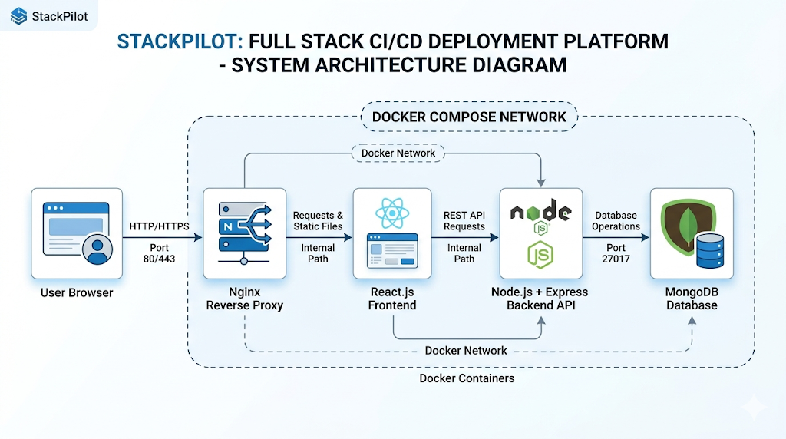
The architecture consists of:
- React.js Frontend Container
- Node.js Backend API Container
- MongoDB Database Container
- Nginx Reverse Proxy
- Docker Network Communication
- Docker Compose Orchestration

6.4 CI/CD Workflow Architecture
The CI/CD workflow automates software integration, testing, Docker image creation, and deployment operations using GitHub Actions and Jenkins. Whenever code is pushed to the GitHub repository, the CI/CD pipeline automatically triggers build and deployment workflows.
The pipeline performs the following operations:
- Source code checkout from GitHub repository.
- Dependency installation and application build.
- Automated testing and validation.
- Docker image creation for frontend and backend services.
- Docker image push to Docker Hub registry.
- Jenkins deployment automation.
- Docker Compose deployment on the target environment.
This automation reduces manual deployment effort and improves software delivery speed and reliability.

6.5 CI/CD Workflow Diagram
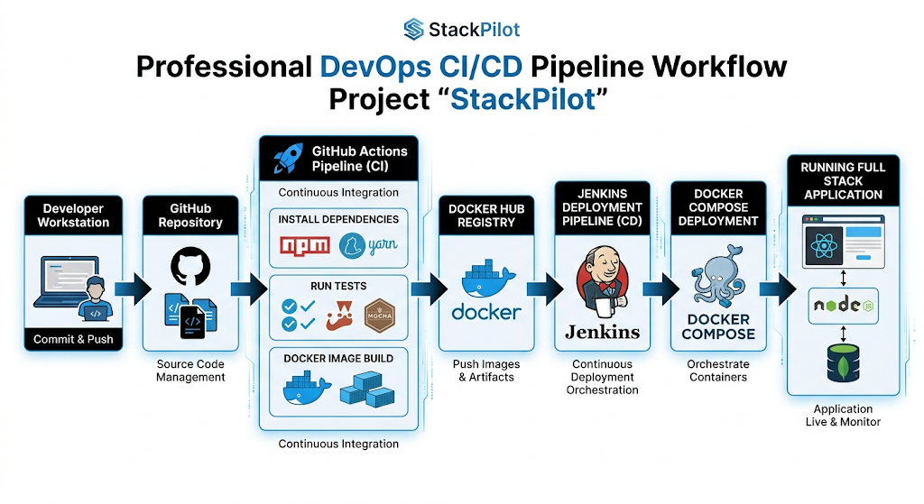
The workflow includes:
- Developer Workstation
- GitHub Repository
- GitHub Actions
- Automated Testing
- Docker Build Process
- Docker Hub Registry
- Jenkins Pipeline
- Docker Compose Deployment
- Running Full Stack Application

7. Technology Stack and Justification

The selection of technologies for this project was based on scalability, automation support, industry relevance, deployment efficiency, and compatibility with modern DevOps practices. The technologies used in this project provide reliable frontend development, backend processing, containerized deployment, and automated CI/CD workflow management.

Technology | Version | Purpose / Justification
React.js | v19.x | Frontend library for building interactive user interfaces
Node.js | v20 LTS | JavaScript runtime for scalable backend services
Express.js | v4.x | Lightweight framework for RESTful API development
MongoDB | v7.x | NoSQL database for flexible data storage
Docker | v25.x | Containerization platform for deployment consistency
Docker Compose | v2.x | Multi-container orchestration and service management
GitHub | Latest | Source code management and version control
GitHub Actions | Latest | Automated CI/CD workflow execution
Jenkins | Latest | Continuous integration and deployment automation
Nginx | v1.25 | Reverse proxy and frontend server
Jest | v29.x | Testing framework for unit and integration testing

7.1 React.js
React.js is used for developing the frontend user interface of the application. It provides a component-based architecture that improves code reusability, maintainability, and frontend performance. React enables efficient rendering and responsive user interaction, making it suitable for modern full-stack web applications.
7.2 Node.js and Express.js
Node.js is a server-side JavaScript runtime environment built on Google’s V8 engine. Its asynchronous and event-driven architecture makes it highly efficient for handling multiple concurrent requests. Express.js simplifies backend development by providing lightweight routing, middleware support, and RESTful API management capabilities.
7.3 MongoDB
MongoDB is a NoSQL document-oriented database used for storing application and deployment-related data. Its flexible schema design allows efficient handling of structured and unstructured data. MongoDB integrates seamlessly with Node.js applications and supports scalable application development.
7.4 Docker and Docker Compose
Docker is used to containerize the frontend, backend, and database services, ensuring portability and consistent execution across different environments. Docker Compose enables the management and orchestration of multiple containers using a single configuration file, simplifying deployment and service communication.
7.5 GitHub Actions and Jenkins
GitHub Actions is used for automating CI/CD workflows including dependency installation, application testing, Docker image creation, and deployment automation. Jenkins is integrated to provide advanced deployment pipeline management and continuous delivery operations. These tools improve deployment reliability and reduce manual intervention during software delivery.

Testing and Validation

A multi-layered testing strategy is implemented to validate the functionality, reliability, and deployment efficiency of the application. Different testing approaches are used to ensure that the frontend, backend, Docker containers, and CI/CD workflows operate correctly and consistently throughout the deployment lifecycle.
8.1 Unit Testing
Unit testing is performed using Jest to validate individual backend functions and application modules independently. The tests focus on API utilities, authentication logic, database operations, and service-level functionality. Mock functions are used to simulate external dependencies and ensure faster execution of test cases. Unit testing helps identify errors early in the development process and improves application reliability.
8.2 API Testing
API testing is conducted to verify the correctness of RESTful API endpoints developed using Node.js and Express.js. The testing process validates request handling, authentication workflows, response generation, and error management. Different API scenarios including successful responses, invalid requests, unauthorized access, and server-side validations are tested to ensure stable backend communication.
8.3 Container Testing
Container testing validates the successful creation and execution of Docker containers for frontend, backend, and database services. Docker Compose is used to build and run all services together in an isolated environment. The testing process verifies inter-container communication, service accessibility, container health status, and successful deployment of the complete application stack.
8.4 CI/CD Pipeline Verification
The CI/CD pipeline is tested using GitHub Actions and Jenkins workflows to ensure successful automation of software delivery processes. The pipeline verifies source code integration, dependency installation, automated testing, Docker image creation, and deployment execution. Failed test cases intentionally introduced during testing confirm that the pipeline correctly blocks deployment operations until errors are resolved. This validation ensures reliable and secure deployment automation throughout the project lifecycle.

9. Results and Outputs
The implementation of the StackPilot: Full Stack CI/CD Deployment Platform successfully demonstrates automated software deployment, containerized application management, and CI/CD workflow integration using modern DevOps technologies. The project achieved stable frontend and backend communication, reliable Docker-based deployment, and automated pipeline execution through GitHub Actions and Jenkins.

9.1 User Registration and Authentication
The authentication module provides secure login and user access management for the deployment platform. The login page contains input fields for username/email and password validation. User credentials are securely processed using backend APIs developed with Node.js and Express.js.
Authentication tokens are generated and validated to maintain secure user sessions and protected access to deployment services. The frontend interface is developed using React.js with a modern responsive design that improves usability and accessibility across devices.
After successful authentication, users are redirected to the main dashboard where deployment monitoring, container management, and CI/CD operations can be accessed.
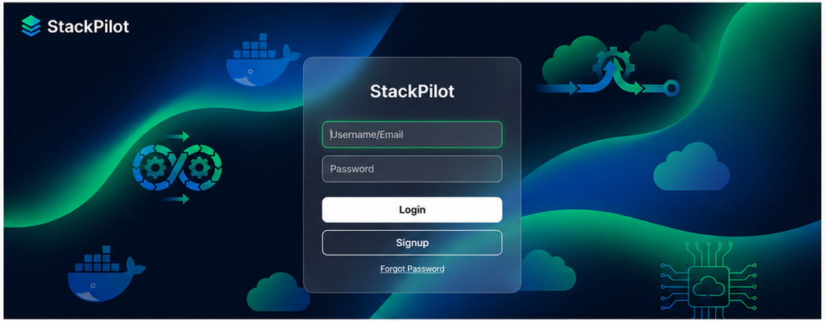

9.2 Dashboard — Deployment Monitoring
The dashboard serves as the central control panel of the application and displays deployment-related information including active services, Docker containers, CI/CD pipeline status, and deployment statistics. Users can monitor deployment workflows, container health, and application status through an interactive frontend interface.
The dashboard includes navigation menus, deployment cards, service indicators, and quick-access controls for efficient management of deployment operations. The interface is developed using React.js with a modern dark-themed DevOps-inspired design suitable for cloud-native application management systems.

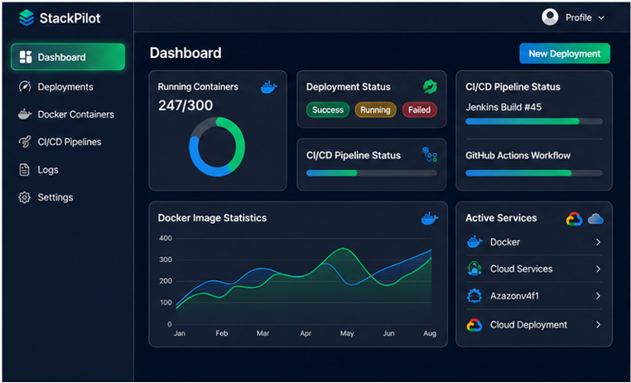
9.3 Deployment Management Interface
The

deployment management module enables users to monitor and manage CI/CD workflows, Docker containers, and deployment operations within a unified interface. The page contains multiple sections including deployment logs, container status panels, CI/CD workflow tracking, and deployment analytics.
The interface is designed to provide responsive and user-friendly deployment management functionality while maintaining a professional DevOps-oriented appearance. Backend APIs integrated with Docker and CI/CD services ensure smooth communication between deployment components and frontend monitoring systems.

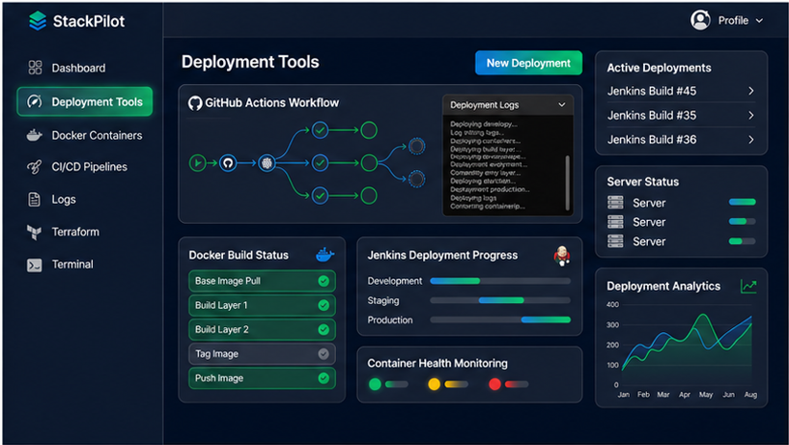
9.4 GitHub Actions Pipeline
The GitHub Actions workflow successfully automates the CI/CD pipeline for the application. The pipeline performs source code checkout, dependency installation, automated testing, Docker image creation, and deployment operations. Each workflow stage executes automatically whenever code changes are pushed to the GitHub repository.
The pipeline dashboard displays successful execution of all CI/CD stages including testing, Docker build operations, image push processes, and deployment validation. Integration with Jenkins further improves deployment automation and continuous delivery management.
(Insert GitHub Actions Pipeline Screenshot Here)

10. Advantages of the System
The StackPilot: Full Stack CI/CD Deployment Platform provides several advantages by integrating modern DevOps practices, containerization technologies, and automated deployment workflows.
- Automated Deployment Pipeline:
The integration of GitHub Actions and Jenkins automates application building, testing, Docker image generation, and deployment processes, significantly reducing manual effort and deployment time.
- Environment Consistency through Docker:
Docker containerization ensures that the application runs consistently across development, testing, and production environments, eliminating dependency and configuration-related issues.
- Improved Software Delivery Speed:
Automated CI/CD workflows accelerate software release cycles and enable faster deployment of application updates with minimal downtime.
- Scalable Containerized Architecture:
The Docker-based architecture allows frontend, backend, and database services to operate independently, improving scalability and maintainability.
- Simplified Multi-Service Management:
Docker Compose enables easy orchestration and management of multiple application containers using a single configuration file.
- Enhanced Deployment Reliability:
Automated testing and pipeline verification improve software quality and reduce the risk of deployment failures in production environments.
- Centralized Version Control and Automation:
GitHub integration provides centralized source code management, workflow automation, and collaboration support for development teams.

11. Limitations
Despite its successful implementation, the current system has certain limitations that can be improved in future development stages.
• Single-Server Deployment:
The application currently runs on a single deployment environment and does not support distributed multi-server deployment or high availability configurations.
• Absence of Kubernetes Integration:
The project uses Docker Compose for orchestration and does not include Kubernetes-based container orchestration or auto-scaling capabilities.
• Limited Monitoring and Logging:
Advanced monitoring, centralized logging, and real-time analytics tools are not integrated into the current implementation.
• Cloud Deployment Limitations:
The application is not fully deployed on cloud-native infrastructure platforms such as AWS, Azure, or Google Cloud.
• Limited DevSecOps Features:
Automated vulnerability scanning, security compliance checks, and advanced DevSecOps practices are not fully implemented.
• No Mobile Application Support:
The project currently focuses on web-based deployment and does not include native mobile application support.

Conclusion
This project successfully demonstrates the design, development, and implementation of StackPilot: Full Stack CI/CD Deployment Platform using modern DevOps technologies including React.js, Node.js, Docker, Docker Compose, GitHub Actions, and Jenkins. The system automates software integration, testing, containerization, and deployment workflows while maintaining deployment consistency across multiple environments.
The implementation of Docker-based containerization resolves common environment inconsistency issues and simplifies application deployment management. The integration of CI/CD pipelines significantly improves deployment efficiency, reduces manual intervention, and enhances software delivery reliability through automated testing and deployment workflows.
From an academic perspective, the project integrates concepts from full-stack development, software engineering, containerization, cloud-native deployment practices, and DevOps automation into a single working system. The project demonstrates how modern deployment technologies and automation workflows can improve software development processes and deployment reliability in contemporary application environments.
Although the current implementation has limitations such as single-server deployment and absence of Kubernetes orchestration, the architecture provides a strong foundation for future scalability, cloud deployment integration, and advanced DevOps enhancements. Overall, the project successfully achieves its objectives and serves as a practical implementation of modern CI/CD and containerized deployment practices used in the software industry.

